27.84: a) 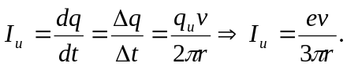
b) 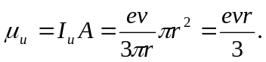
c) Since there are two down quarks, each of half the charge of the up quark,

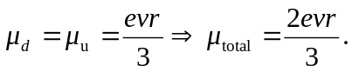
d) 